**LAB6**

Simran

100377444

Q1: Display the name of students who enrolled in at least one section.

ANS: SELECT DISTINCT student.sName

FROM student JOIN std_enrolls_sec

ON std_enrolls_sec.sid = student.sid;

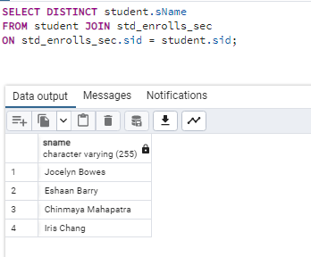

Q2: Retrieve Course ID, section ID, and Section Type of the sections that have been enrolled by at least one student

ANS: SELECT DISTINCT(std_enrolls_sec.cId), std_enrolls_sec.secId, course_section.sType

FROM std_enrolls_sec LEFT JOIN course_section

ON std_enrolls_sec.cId = course_section.cId;

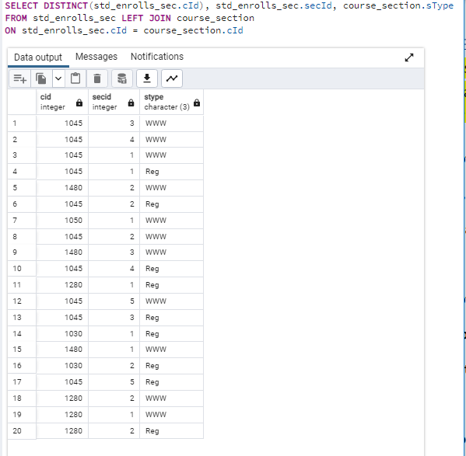

Q3: Display CIS, SecID, and SType of all sections (no matter if a student has enrolled in that section or not) and the name of students who enrolled in that section.

ANS: SELECT DISTINCT course_section.cId, course_section.secId, course_section.sType, student.sName

FROM std_enrolls_sec, course_section, student

WHERE std_enrolls_sec.cId = course_section.cId

AND std_enrolls_sec.sId = student.sId;

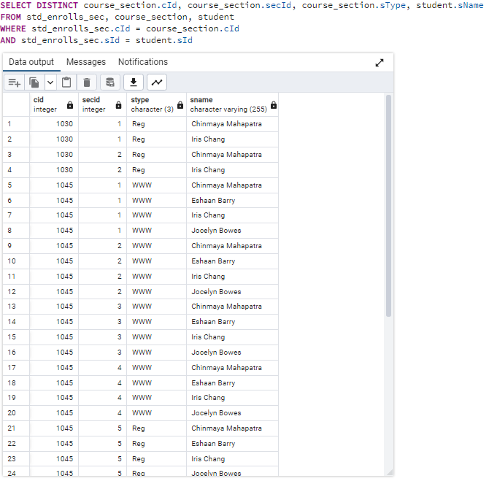

Q4: Display the name of all students(no matter if they have enrolled in any section) and the section number of all sections that they have enrolled.

ANS: SELECT student.sName, std_enrolls_sec.secId

FROM student LEFT JOIN std_enrolls_sec

ON student.sId = std_enrolls_sec.sId;

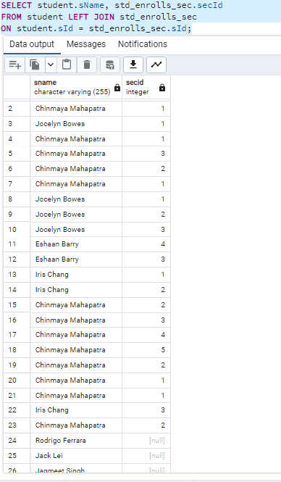

Q5: Display the name of all students and all sections they have enrolled (no matter if a student has enrolled in any section and no matter if a section was enrolled by any student)

ANS: SELECT student.sName, std_enrolls_sec.secId

FROM student FULL JOIN std_enrolls_sec

ON student.sId = std_enrolls_sec.sId;

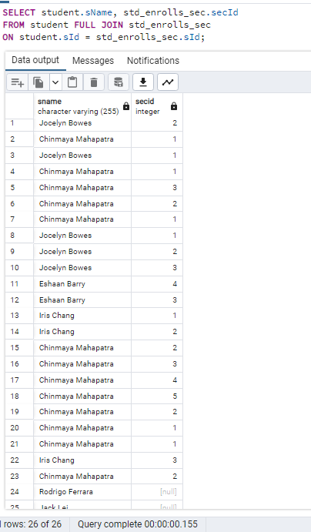

Q6: Display the name of student who have not enrolled in any section?

ANS: SELECT student.sName

FROM student LEFT JOIN std_enrolls_sec

ON student.sId = std_enrolls_sec.sId

WHERE std_enrolls_sec.secid IS NULL ;

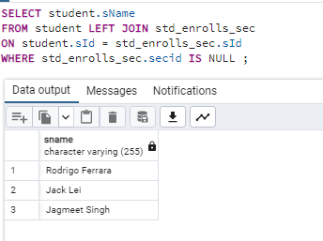

Q7: Display the name of section which has not be enrolled by any student?

ANS: SELECT CS.secId

FROM std_enrolls_sec SE RIGHT JOIN course_section CS

ON SE.cId = CS.cId

WHERE SE.sId IS NULL;

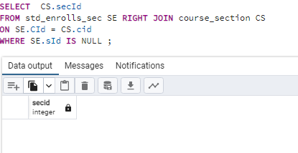

Q8: Retrieve the name of student and number of sections that they have enrolled

ANS: SELECT S.Sname, COUNT(SE.secId)

FROM student S , std_enrolls_sec SE

WHERE S.sId = SE.sId

GROUP BY S.sName;

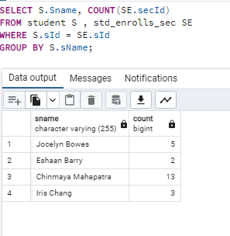

Q9: Retrieve the name of students who have taken all courses

ANS: SELECT S.sName

FROM student S , std_enrolls_sec SE

WHERE S.sId = SE.sId

GROUP BY S.sName

HAVING COUNT(SE.secId) = (SELECT COUNT(secId) FROM course_section);

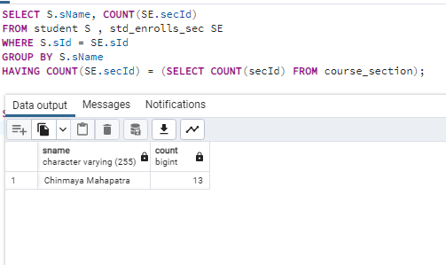

Q10: Retrieve the CID of courses and the number of students who enrolled in those sections

ANS: SELECT C.cId, COUNT(SE.sId)

FROM course C, std_enrolls_sec SE

WHERE C.cId = SE.cId

GROUP BY C.cId;

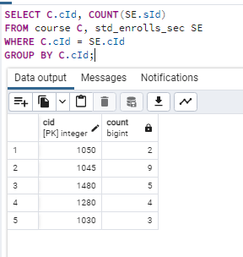

Q11: Retrieve the name of students who are classmates with ‘Chinmaya Mahapatra’ in all sections that he has enrolled.

ANS: SELECT DISTINCT S.sName

FROM student S, std_enrolls_sec SE

WHERE S.sId = SE.sId

AND S.sName <> 'Chinmaya Mahapatra'

AND EXISTS(

SELECT SE.cId, SE.secId

FROM student S

JOIN std_enrolls_sec SE

ON S.sId = SE.sid

WHERE S.sName = 'Chinmaya Mahapatra');

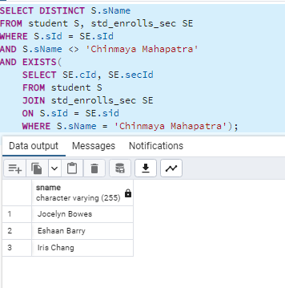

Q12: Retrieve the name of all students who enrolled in 1045-001

ANS: SELECT S.sName

FROM student S, std_enrolls_sec SE

WHERE S.sId = SE.sId

AND SE.cId = '1045'

AND SE.secId = '1';

